VIAHALE: TRANSPORT NETWORK VEHICLE SERVICE CORE I SYSTEM WITH PREDICTIVE DISPATCHING AND DYNAMIC
TRIP MATCHING USING AI FORECASTING POWERED
BY TENSORFLOW AND SCIKIT-LEARN

A Capstone
Presented to the Faculty of
The College of Computer Studies
Bestlink College of the Philippines

In Partial Fulfilment
of the Requirements for the Degree
Bachelor of Science in Information Technology

FIRSTNAME M.I. LASTNAME
FIRSTNAME M.I. LASTNAME
FIRSTNAME M.I. LASTNAME
FIRSTNAME M.I. LASTNAME
FIRSTNAME M.I. LASTNAME

September 2025
APPROVAL SHEET

This capstone entitled VIAHALE: TRANSPORT NETWORK VEHICLE SERVICE CORE I SYSTEM WITH PREDICTIVE DISPATCHING AND DYNAMIC TRIP MATCHING USING AI FORECASTING POWERED BY TENSORFLOW AND SCIKIT-LEARN , prepared and submitted by Lislyan M. Dela Cruz, Cristianber B. Gordora, Leandro C. Quisado, Jeffrey T. Tatoy, and Richelyn A. Villasor, in partial fulfilment of the requirements for the degree of Bachelor of Science in Information Technology, has been examined and is recommended for acceptance and approval Oral Defense.

RICHELYN A. VILLASOR
Adviser
CAPSTONE REVIEW PANEL
Approved by the Committee on Oral Examination with a grade of

REYNANTE B. PONAY, CpE VINCENT CARLO T. GARADOS
Member Member

ROMMEL J. CONSTANTINO, DIT
Chairperson

Accepted and approved in partial fulfillment of the requirements for the degree of Bachelor of Science in Information Technology.

ROSICAR E. ESCOBER, Ph. D
Dean, College of Computer Studies
Date of Final Defense:
ACKNOWLEDGEMENT
The researchers would like to express their heartfelt thanks and gratitude to the following persons who, in one way or another, has contributed much, and extended willingness and support needed to make this research possible:
Dr. Maria M. Vicente, President/CEO, Bestlink College of the Philippines, for her generosity and kind heart in establishing this institution and giving opportunities to those less fortunate students to continue their studies and pursue their dreams;
Ms. Edith M. Vicente, Executive Vice President, for providing the needed information to complete this research;
Dr. Charlie I. Cariño, Vice President for Academic Affairs, for his support and encouragement to make this thesis writing possible;
Engr. Diosdado T. Lleno, Vice President for Administration and
Finance, for his words of encouragement and motivation;
Dr. Joy Evelyn A. Ignacio, College Associate Research Head, for her good heart to extend her help needed by the researchers.
Dr. Rosicar E. Escober, Dean, College of Computer Studies of Bestlink College of the Philippines, for providing a guideline documentation in capstone project.
Dr. Rommel J. Constantino, Program Head, Bachelor of Science in Information Technology, for the constant supervision as well as providing necessary information regarding the project and also for his support in completing this project
Ms. Richelyn A. Villasor, Research Coordinator, for helping us in improving our research and guiding us in completing this project.
Ms. Richelyn A. Villasor, Capstone Adviser, for giving us suggestions and ideas to improve our research and guiding us in completing this project.
Panelists, Mr. Vincent Carlo T. Garados, Engr. Reynante B. Ponay, and Dr. Rommel J. Constantino, who extended their effort and time to be able to constructively criticize this thesis and share their knowledge with them to deepen and widen their needed information.
Families and Friends, for all the financial and moral support that have enabled the researchers to triumph all the challenges, especially during the lowest time that served as their inspiration to complete this study; and
Above all, to the Almighty God, for the strength and knowledge that were used for the accomplishment of this research journey.

THE RESEARCHERS
DEDICATION
This business research study is wholeheartedly dedicated first and foremost to the researchers, for executing dedication, time, effort, motivation, sacrifice, and courage to make this conducting study a fruitful and successful piece of work.
To our beloved parents who have been our inspiration and gave us strength when we thought of giving up, which continually provide their moral, spiritual, emotional and financial support.
To each sibling and circle of friends who shared their words of advice and encouragement to finish this study.
To the research advisers and professors, for extending help by giving guidance, supervision, time and wisdom to the researchers in conducting this business research study.
And lastly, above all, to our Almighty God, for giving guidance, strength, power of mind, protection, skills and for giving us a healthy life. All of these we offer to you.
THE RESEARCHERS

ABSTRACT
Title: GOVERNMENT SERVICE MANAGEMENT SYSTEM: SMART REVENUE TRACKER WITH AI-BASED ANOMALY DETECTION USING ML.JS
Authors: IVAN D. ANORICO
HANZ VERNE R. CELLONA
SHANNY BHELL O. DE LARA
JERICK R. GENOSAS
SHERILYN MAE B. PARES
Degree: Bachelor of Science of Information Technology
Major: Information Management, Information Security, Network
Administrative
Date of Completion:

IMRAD TYPE Lorem ipsum dolor sit amet, consectetur adipiscing elit, sed do eiusmod tempor incididunt ut labore et dolore magna aliqua. Ut enim ad minim veniam, quis nostrud exercitation ullamco laboris nisi ut aliquip ex ea commodo consequat. Duis aute irure dolor in reprehenderit in voluptate velit esse cillum dolore eu fugiat nulla pariatur. Excepteur sint occaecat cupidatat non proident, sunt in culpa qui officia deserunt mollit anim id est laborum
Lorem ipsum dolor sit amet, consectetur adipiscing elit, sed do eiusmod tempor incididunt ut labore et dolore magna aliqua. Ut enim ad minim veniam, quis nostrud exercitation ullamco laboris nisi ut aliquip ex ea commodo consequat. Duis aute irure dolor in reprehenderit in voluptate velit esse cillum dolore eu fugiat nulla pariatur. Excepteur sint occaecat cupidatat non proident, sunt in culpa qui officia deserunt mollit anim id est laborum.

TABLE OF CONTENTS
Page
TITLE PAGE i
APPROVAL SHEET ii
ACKNOWLEDGMENT iii
DEDICATION v
ABSTRACT vi
TABLE OF CONTENTS viii
LIST OF TABLES xiii
LIST OF FIGURES xiv
LIST OF APPENDICES xv
CHAPTER
1 INTRODUCTION
1.1. Background of the Capstone Project 1
1.2. Context and Scope 3
1.3. Problem Statement 7
1.4. Objectives and Goals 8
1.5. Significance and Relevance 10
1.6. Structure of the Document 12

CHAPTER
2 REVIEW OF RELATED LITERATURE
2.1. Agile Scrum Methodology Overview 14
2.2. Enterprise Architecture Concepts 16
2.3. Microservices Architecture 18
2.4 DevOps and CI/CD 18
2.5 Relevant Studies and Research 20
2.6 Integration of Information Systems in 24
Enterprise Environment
CHAPTER
3 METHODOLOGY
3.1. Agile Scrum Methodology in the Project 25
3.2. Roles (e.g., Scrum Master, Product Owner, 27
Development Team)
3.3. Sprint Cycles (e.g., Sprint Planning, 31
Daily Standups, Sprint Review)
3.4. Scrum Artifacts 37
3.5 Microservices Architecture 77
3.6 DevOps Implementation 82
3.7 Integration Approach for Information Systems 87
3.8 Introduction to TOGAF and the Four 90
Architectural Domains
CHAPTER
4 REQUIREMENTS ANALYSIS
4.1. Stakeholder Identification
4.2. Requirements Gathering Techniques
4.3. User Stories and Use Cases
4.4. Functional Requirements for Integration
5. Business Process Architecture
5.1. Identification of Business Processes
5.2. Business Process Diagrams
5.3. Alignment of Integrated System with
Business Processes
5.4. Business Process Improvements
6. Application Architecture
6.1. Components of Application Architecture
6.2. Application Architecture Diagrams
6.3. Integration of Software Modules
6.4. Communication and Interaction Patterns
7. Data Architecture
7.1. Data Sources and Types
7.2. Data Flow Diagrams
7.3. Data Storage and Management
7.4. Data Synchronization Across Systems
8. Technology Architecture
8.1 Technology Stack and Infrastructure
8.2 Software Technologies
8.3. Scalability and Performance Considerations
9. Development Process
9.1. Agile Scrum Roles and Responsibilities
9.2. Sprint Planning and Backlog Management
9.3. Sprint Execution and Deliverables
9.4. Challenges Faced In the Development Process
10. Implementation
10.1. Technical Implementation Details
10.2. Tools and Technologies Used
10.3. Code Integration and Interoperability
10.4. Integration Testing and Debugging
11. Testing and Quality Assurance
11.1. Testing Strategies and Methodologies
11.2. Test Cases and Test Data
11.3. Test Results and Bug Reports
11.4. Quality Assurance Measures
12. Results and Evaluation
12.1. Project Outcomes and Deliverables
12.2. Alignment with Project Objectives
12.3 Stakeholder and User Feedback
12.4. Lessons Learned
CHAPTER
5 CONCLUSION
13.1. Key Takeaways and Summary
13.2. Project Achievements and Contributions
13.3. Future Work and Enhancements
13.4. Closing Remarks
REFERENCES
APPENDICES
CURRICULUM VITAE

LIST OF TABLES
Table Page
- Roles and Responsibilities 27
- Sprint Cycle 33
- Product Backlog (User Stories) 37
- Product Backlog for EIS Information Security 47
- Product Backlog for EIS Standards 49
- Product Backlog for EIS Integration 51
- Product Backlog for Analytics 56
- Product Backlog for EIS Analytics 58
- Sprint Backlog (User Stories) 60
- Scrum Board 73

LIST OF FIGURES
Figure Page
- Agile Scrum Framework 26
- Burndown Chart 76
- Microservices Diagram 79
- Communication Pattern 80
- Data Flow Diagram 81
- CI/CD Pipeline 85
- Infrastructure as a Code (IaC) 85
- Monitoring and Alerting 86
- Integration Diagram 88
- API Gateway 88
- Data Flow Diagram 89
- Use Case Diagram 92
- Sequence Diagram 93
- Flowchart 93

LIST OF APPENDICES
Appendix A Detailed Technical Documentation
Appendix B Documents/URLs
Appendix C Certificate of Originality
Appendix D Certificate of Grammarian
Appendix E Grammarian Curriculum Vitae
Appendix F Technical Adviser Curriculum Vitae
Appendix G Research Adviser Curriculum Vitae
Appendix H Researcher’s Curriculum Vitae

Chapter 1
INTRODUCTION
1.1 Background of the Capstone Project
Lorem ipsum dolor sit amet, consectetur adipiscing elit, sed do eiusmod tempor incididunt ut labore et dolore magna aliqua. Ut enim ad minim veniam, quis nostrud exercitation ullamco laboris nisi ut aliquip ex ea commodo consequat. Duis aute irure dolor in reprehenderit in voluptate velit esse cillum dolore eu fugiat nulla pariatur. Excepteur sint occaecat cupidatat non proident, sunt in culpa qui officia deserunt mollit anim id est laborum
Sed ut perspiciatis unde omnis iste natus error sit voluptatem accusantium doloremque laudantium, totam rem aperiam, eaque ipsa quae ab illo inventore veritatis et quasi architecto beatae vitae dicta sunt explicabo. Nemo enim ipsam voluptatem quia voluptas sit aspernatur aut odit aut fugit, sed quia consequuntur magni dolores eos qui ratione voluptatem sequi nesciunt. Neque porro quisquam est, qui dolorem ipsum quia dolor sit amet, consectetur, adipisci velit, sed quia non numquam eius modi tempora incidunt ut labore et dolore magnam aliquam quaerat voluptatem. Ut enim ad minima veniam, quis nostrum exercitationem ullam corporis suscipit laboriosam, nisi ut aliquid ex ea commodi consequatur? Quis autem vel eum iure reprehenderit qui in ea voluptate velit esse quam nihil molestiae consequatur, vel illum qui dolorem eum fugiat quo voluptas nulla pariatur
At vero eos et accusamus et iusto odio dignissimos ducimus qui blanditiis praesentium voluptatum deleniti atque corrupti quos dolores et quas molestias excepturi sint occaecati cupiditate non provident, similique sunt in culpa qui officia deserunt mollitia animi, id est laborum et dolorum fuga. Et harum quidem rerum facilis est et expedita distinctio. Nam libero tempore, cum soluta nobis est eligendi optio cumque nihil impedit quo minus id quod maxime placeat facere possimus, omnis voluptas assumenda est, omnis dolor repellendus. Temporibus autem quibusdam et aut officiis debitis aut rerum necessitatibus saepe eveniet ut et voluptates repudiandae sint et molestiae non recusandae. Itaque earum rerum hic tenetur a sapiente delectus, ut aut reiciendis voluptatibus maiores alias consequatur aut perferendis doloribus asperiores repellat.

1.2 Context and Scope
Lorem ipsum dolor sit amet, consectetur adipiscing elit, sed do eiusmod tempor incididunt ut labore et dolore magna aliqua. Ut enim ad minim veniam, quis nostrud exercitation ullamco laboris nisi ut aliquip ex ea commodo consequat. Duis aute irure dolor in reprehenderit in voluptate velit esse cillum dolore eu fugiat nulla pariatur. Excepteur sint occaecat cupidatat non proident, sunt in culpa qui officia deserunt mollit anim id est laborum
To be focused and achievable in implementation, the project scope shall involve:
- Lorem ipsum dolor sit amet,\
- consectetur adipiscing elit, sed do eiusmod tempor incididunt ut labore et dolore magna aliqua. Ut enim ad minim veniam, quis nostrud exercitation ullamco laboris nisi ut aliquip ex ea commodo consequat. Duis aute irure dolor in reprehenderit in voluptate velit esse cillum dolore eu fugiat nulla pariatur. Excepteur sint occaecat cupidatat non proident, sunt in culpa qui officia deserunt mollit anim id est laborum

Out of Scope:
  - Blal=blahlanaksba
  - Blal=blahlanaksba
  - Blal=blahlanaksba
  - Blal=blahlanaksba
  - Blal=blahlanaksba

1.3 Problem Statement
At vero eos et accusamus et iusto odio dignissimos ducimus qui blanditiis praesentium voluptatum deleniti atque corrupti quos dolores et quas molestias excepturi sint occaecati cupiditate non provident, similique sunt in culpa qui officia deserunt mollitia animi, id est laborum et dolorum fuga. Et harum quidem rerum facilis est et expedita distinctio. Nam libero tempore, cum soluta nobis est eligendi optio cumque nihil impedit quo minus id quod maxime placeat facere possimus, omnis voluptas assumenda est, omnis dolor repellendus. Temporibus autem quibusdam et aut officiis debitis aut rerum necessitatibus saepe eveniet ut et voluptates repudiandae sint et molestiae non recusandae. Itaque earum rerum hic tenetur a sapiente delectus, ut aut reiciendis voluptatibus maiores alias consequatur aut perferendis doloribus asperiores repellat.
- jabdbakfn
- kanfknesed
- anegwieohoisb
- aivjbjssjd
- najvsbsdjvsndvjsd
1.4 Objectives and Goals
At vero eos et accusamus et iusto odio dignissimos ducimus qui blanditiis praesentium voluptatum deleniti atque corrupti quos dolores et quas molestias excepturi sint occaecati cupiditate non provident, similique sunt in culpa qui officia deserunt mollitia animi, id est laborum et dolorum fuga. Et harum quidem rerum facilis est et expedita distinctio.
- skdkslkslslk4s fbks klb sdvmsklld skldmsk klsdksmdk s msd ks s d kd kd fdf ldf fdflk mdfk.
- skdkslkslslk4s fbks klb sdvmsklld skldmsk klsdksmdk s msd ks s d kd kd fdf ldf fdflk mdfk.
- skdkslkslslk4s fbks klb sdvmsklld skldmsk klsdksmdk s msd ks s d kd kd fdf ldf fdflk mdfk
1.5 Significance and Relevance
Lorem ipsum dolor sit amet, consectetur adipiscing elit, sed do eiusmod tempor incididunt ut labore et dolore magna aliqua. Ut enim ad minim veniam, quis nostrud exercitation ullamco laboris nisi ut aliquip ex ea commodo consequat.
Key beneficiaries include:
Future Researcher: Lorem ipsum dolor sit amet, consectetur adipiscing elit, sed do eiusmod tempor incididunt ut labore et dolore magna aliqua. Ut enim ad minim veniam, quis nostrud exercitation ullamco laboris nisi ut aliquip ex ea commodo consequat.
1.6 Structure of the Document
Lorem ipsum dolor sit amet, consectetur adipiscing elit, sed do eiusmod tempor incididunt ut labore et dolore magna aliqua. Ut enim ad minim veniam, quis nostrud exercitation ullamco laboris nisi ut aliquip ex ea commodo consequat.
Chapter 1: Introduction - Lorem ipsum dolor sit amet, consectetur adipiscing elit, sed do eiusmod tempor incididunt ut labore et dolore magna aliqua. Ut enim ad minim veniam, quis nostrud exercitation ullamco laboris nisi ut aliquip ex ea commodo consequat.
Chapter 2: Review of Related Literature - Lorem ipsum dolor sit amet, consectetur adipiscing elit, sed do eiusmod tempor incididunt ut labore et dolore magna aliqua. Ut enim ad minim veniam, quis nostrud exercitation ullamco laboris nisi ut aliquip ex ea commodo consequat. detection, putting this project in the larger context of research.
Chapter 3: Methodology - Lorem ipsum dolor sit amet, consectetur adipiscing elit, sed do eiusmod tempor incididunt ut labore et dolore magna aliqua. Ut enim ad minim veniam, quis nostrud exercitation ullamco laboris nisi ut aliquip ex ea commodo consequat.
Chapter 4: Requirement Analysis - Lorem ipsum dolor sit amet, consectetur adipiscing elit, sed do eiusmod tempor incididunt ut labore et dolore magna aliqua. Ut enim ad minim veniam, quis nostrud exercitation ullamco laboris nisi ut aliquip ex ea commodo consequat.
Chapter 5: Conclusion and Recommendations - Lorem ipsum dolor sit amet, consectetur adipiscing elit, sed do eiusmod tempor incididunt ut labore et dolore magna aliqua. Ut enim ad minim veniam, quis nostrud exercitation ullamco laboris nisi ut aliquip ex ea commodo consequat.

Chapter 2
REVIEW OF RELATED LITERATURE
2.1 Agile Scrum Methodology Overview
Lorem ipsum dolor sit amet, consectetur adipiscing elit, sed do eiusmod tempor incididunt ut labore et dolore magna aliqua. Ut enim ad minim veniam, quis nostrud exercitation ullamco laboris nisi ut aliquip ex ea commodo consequat.
The three pillars, according to Schwaber, K, & Sutherland, J. (2020), Lorem ipsum dolor sit amet, consectetur adipiscing elit, sed do eiusmod tempor incididunt ut labore et dolore magna aliqua. Ut enim ad minim veniam, quis nostrud exercitation ullamco laboris nisi ut aliquip ex ea commodo consequat.
Overall, Agile Scrum assisted us Lorem ipsum dolor sit amet, consectetur adipiscing elit, sed do eiusmod tempor incididunt ut labore et dolore magna aliqua. Ut enim ad minim veniam, quis nostrud exercitation ullamco laboris nisi ut aliquip ex ea commodo consequat.

2.2 Enterprise Architecture Concepts
Lorem ipsum dolor sit amet, consectetur adipiscing elit, sed do eiusmod tempor incididunt ut labore et dolore magna aliqua. Ut enim ad minim veniam, quis nostrud exercitation ullamco laboris nisi ut aliquip ex ea commodo consequat.
Lorem ipsum dolor sit amet, consectetur adipiscing elit, sed do eiusmod tempor incididunt ut labore et dolore magna aliqua. Ut enim ad minim veniam, quis nostrud exercitation ullamco laboris nisi ut aliquip ex ea commodo consequat. sers and will be able to be scaled and maintained in the future.

2.3 Microservices Architecture
Lorem ipsum dolor sit amet, consectetur adipiscing elit, sed do eiusmod tempor incididunt ut labore et dolore magna aliqua. Ut enim ad minim veniam, quis nostrud exercitation ullamco laboris nisi ut aliquip ex ea commodo consequat.
2.4 DevOps and CI/CD
Lorem ipsum dolor sit amet, consectetur adipiscing elit, sed do eiusmod tempor incididunt ut labore et dolore magna aliqua. Ut enim ad minim veniam, quis nostrud exercitation ullamco laboris nisi ut aliquip ex ea commodo consequat.
Lorem ipsum dolor sit amet, consectetur adipiscing elit, sed do eiusmod tempor incididunt ut labore et dolore magna aliqua. Ut enim ad minim veniam, quis nostrud exercitation ullamco laboris nisi ut aliquip ex ea commodo consequat.

2.5 Relevant Studies and Research
Lorem ipsum dolor sit amet, consectetur adipiscing elit, sed do eiusmod tempor incididunt ut labore et dolore magna aliqua. Ut enim ad minim veniam, quis nostrud exercitation ullamco laboris nisi ut aliquip ex ea commodo consequat.
Local Studies
Andaya (2025), Lorem ipsum dolor sit amet, consectetur adipiscing elit, sed do eiusmod tempor incididunt ut labore et dolore magna aliqua. Ut enim ad minim veniam, quis nostrud exercitation ullamco laboris nisi ut aliquip ex ea commodo consequat.
Leah A. Bayona and Ma. Theresa B. Ballados (2025), Lorem ipsum dolor sit amet, consectetur adipiscing elit, sed do eiusmod tempor incididunt ut labore et dolore magna aliqua. Ut enim ad minim veniam, quis nostrud exercitation ullamco laboris nisi ut aliquip ex ea commodo consequat..
Foreign Studies
Aldemir and Uysal (2025), Lorem ipsum dolor sit amet, consectetur adipiscing elit, sed do eiusmod tempor incididunt ut labore et dolore magna aliqua. Ut enim ad minim veniam, quis nostrud exercitation ullamco laboris nisi ut aliquip ex ea commodo consequat.
Zheng and O’Penetrante (2025), Lorem ipsum dolor sit amet, consectetur adipiscing elit, sed do eiusmod tempor incididunt ut labore et dolore magna aliqua. Ut enim ad minim veniam, quis nostrud exercitation ullamco laboris nisi ut aliquip ex ea commodo consequat.
2.6 Integration of Information Systems in Enterprise Environment
Lorem ipsum dolor sit amet, consectetur adipiscing elit, sed do eiusmod tempor incididunt ut labore et dolore magna aliqua. Ut enim ad minim veniam, quis nostrud exercitation ullamco laboris nisi ut aliquip ex ea commodo consequat.

Chapter 3
METHODOLOGY
3.1 Agile Scrum Methodology in the Project
Lorem ipsum dolor sit amet, consectetur adipiscing elit, sed do eiusmod tempor incididunt ut labore et dolore magna aliqua. Ut enim ad minim veniam, quis nostrud exercitation ullamco laboris nisi ut aliquip ex ea commodo consequat.
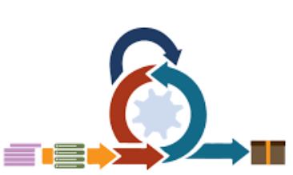
Figure no. 1 Agile Scrum Framework

3.2 Roles and Responsibilities
Each role in the project team carries significant responsibilities that directly influence the success and overall performance of the capstone project. The table below outlines the key duties assigned to each team member:
Name | Role | Responsibilities
Ms. Richelyn Villasor | Research Adviser | Sed ut perspiciatis unde omnis iste natus error sit voluptatem accusantium doloremque laudantium, totam rem aperiam, eaque ipsa quae ab illo inventore veritatis et quasi architecto beatae vitae dicta sunt explicabo.
Ms. Richelyn Villasor | Product Owner | Sed ut perspiciatis unde omnis iste natus error sit voluptatem accusantium doloremque laudantium, totam rem aperiam, eaque ipsa quae ab illo inventore veritatis et quasi architecto beatae vitae dicta sunt explicabo.
Ms. Richelyn Villasor | Project Manager | Sed ut perspiciatis unde omnis iste natus error sit voluptatem accusantium doloremque laudantium, totam rem aperiam, eaque ipsa quae ab illo inventore veritatis et quasi architecto beatae vitae dicta sunt explicabo.
Ms. Richelyn Villasor | Developer/Lead Programmer | Sed ut perspiciatis unde omnis iste natus error sit voluptatem accusantium doloremque laudantium, totam rem aperiam, eaque ipsa quae ab illo inventore veritatis et quasi architecto beatae vitae dicta sunt explicabo.
Ms. Richelyn Villasor | QA Tester | Sed ut perspiciatis unde omnis iste natus error sit voluptatem accusantium doloremque laudantium, totam rem aperiam, eaque ipsa quae ab illo inventore veritatis et quasi architecto beatae vitae dicta sunt explicabo.
Ms. Richelyn Villasor | Documentation Specialist | Sed ut perspiciatis unde omnis iste natus error sit voluptatem accusantium doloremque laudantium, totam rem aperiam, eaque ipsa quae ab illo inventore veritatis et quasi architecto beatae vitae dicta sunt explicabo.
Ms. Richelyn Villasor | Security Lead | Sed ut perspiciatis unde omnis iste natus error sit voluptatem accusantium doloremque laudantium, totam rem aperiam, eaque ipsa quae ab illo inventore veritatis et quasi architecto beatae vitae dicta sunt explicabo.
Table no.1 Roles and Responsibilities

3.3 Sprint Cycles
Sed ut perspiciatis unde omnis iste natus error sit voluptatem accusantium doloremque laudantium, totam rem aperiam, eaque ipsa quae ab illo inventore veritatis et quasi architecto beatae vitae dicta sunt explicabo.
To Do | In Progress | Done
Table no. 2 Scrum Board

3.4 Scrum Artifacts
3.4.1 Product Backlog (User Stories)
User Story No. | Features/ Task | User Stories | Priority | Status
MODULE 1
F1
F2
F10
MODULE 2
F11
F20
MODULE 3
F21
F30
MODULE 4
F31
F40
Table no. 3 Product Backlog

3.4.2 Product Backlog for EIS Information Security
EIS No. | EIS User Stories | EIS IS Priority | Revision Priority | Status
IS-1 |  | 1 | 1
IS-2 |  | 1 | 2
IS-3 |  | 1 | 2
Table no. 4 Product Backlog for EIS Information Security
3.4.3 Product Backlog for EIS Standards
3.4.3.1 UI/UX (Icons, Color, etc…)
EIS Standard No. | EIS Standard User Stories | EIS Standard Priority | Revision Priority | Status
UI-1
UI-2
UI-3
Table no. 5 Product Backlog for EIS Standards

3.4.4 Product Backlog for EIS Integration
EIS Integration No. | EIS Integration User Stories | EIS Integration Priority | Revision Priority | Status
INT-1
INT-2
INT-3
Table no. 6 Product Backlog for EIS Integration
3.4.5 Product Backlog for Analytics
3.4.5.1 Application System Analytics
EIS Integration No. | EIS Integration User Stories | EIS Integration Priority | Revision Priority | Status
ASA-1
ASA-2
ASA-3
Table no. 7 Product Backlog for Analytics
3.4.5.2 EIS Analytics
EIS Analytics No. | EIS Analytics Stories | EIS Analytics Priority | Revision Priority | Status
EA-1
EA-2
EA-3
Table no.8 EIS Analytics

3.4.6 Sprint Backlog (User Stories)
Task No. | User Story No. | User Stories | Tasks | Timeline | Responsible Team Member/s
SPRINT 1
S1_1 | IS-1 |  | PLANNING  DESIGN  CODE  DOCUMENTATION
S1_2 | IS-2
S1_3 | F-1
S1_4 | F2
S1_5 | F-3
SPRINT 2
S2_1 | IS-3 |  | PLANNING  DESIGN  CODE  DOCUMENTATION
S2_2 | IS-4
S2_3 | F-4
S2_4 | F5
S2_5 | F-6

Table no. 9 Sprint Backlog (User Stories)

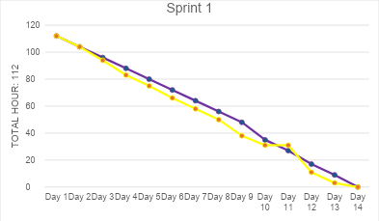
3.4.6.1 Sprint Burndown Chart

Figure no. 2 Burndown Chart

3.4.7. Increment
Sprint No. | Increment / Feature Delivered |  | User Story / Backlog Reference | Definition of Done (DoD) Criteria | Status | Remarks
Sprint 1 | User Registration & Login Module | IS-1, IS-2 |  | Code completed  - Unit tested  - Integrated with DB  - Documentation updated | Done | Basic authentication working
Sprint 1 | Database Schema Setup | F-1 |  | - Schema created  - Tables normalized  - Tested with sample data | Done
  Ready for integration
Sprint 2 | Product Catalog Module | IS-3, IS-4 |  | - UI designed  - CRUD operations functional  - Tested on staging | In Progress | Pending UI review
Sprint 2 | Shopping Cart | F-4 |  | - Add/remove items working  - Cart persists in session  - Unit tested | In Progress | Needs integration with checkout
Sprint 3 | Checkout & Payment Integration | IS-5, F-5 |  | - Payment gateway connected  - Security tested (SSL)  - Error handling in place | Planned | To be developed in Sprint 3

Table no. Increment

3.5 Microservices Architecture
orem ipsum dolor sit amet, consectetur adipiscing elit, sed do eiusmod tempor incididunt ut labore et dolore magna aliqua. Ut enim ad minim veniam, quis nostrud exercitation ullamco laboris nisi ut aliquip ex ea commodo consequat. Duis aute irure dolor in reprehenderit in voluptate velit esse cillum dolore eu fugiat nulla pariatur.
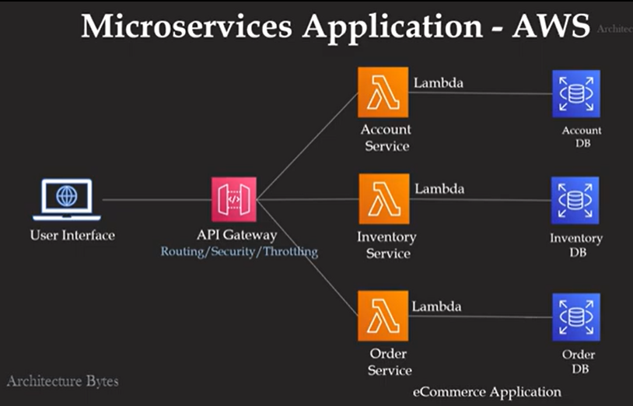

Figure no. 3 Microservices Diagram

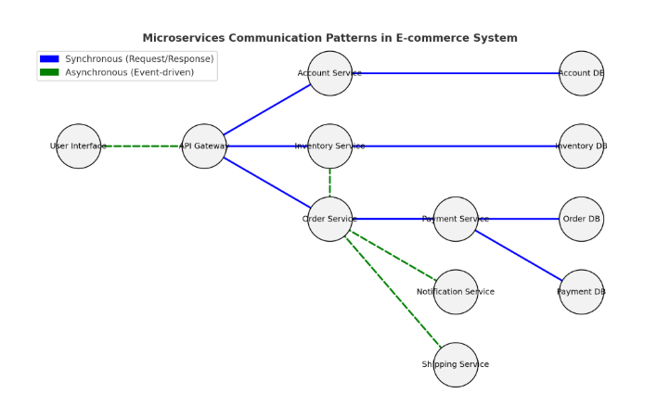
Figure no. 4 Communication Pattern for Microservices
Here’s the communication pattern diagram for an e-commerce microservices system:
- 🔵 Blue solid lines → Synchronous (Request/Response) calls (e.g., login, product search, payment validation).
- 🟢 Green dashed lines → Asynchronous (Event-driven) interactions (e.g., order triggers stock updates, shipping, notifications).

Dfd level 1
Level 1 DFD (Context Diagram)
This shows the entire e-commerce system as one process and how external entities interact with it.
- External Entity: Customer
- System (Process): E-commerce Microservices System
- Data Stores: Account DB, Inventory DB, Order DB, Payment DB
- Data Flows: Login, Browse Products, Place Order, Make Payment, Receive Notification, Shipping Info
Figure no. 5 Data Flow Diagram for Microservices

3.6 DevOps Implementation
Lorem ipsum dolor sit amet, consectetur adipiscing elit, sed do eiusmod tempor incididunt ut labore et dolore magna aliqua. Ut enim ad minim veniam, quis nostrud exercitation ullamco laboris nisi ut aliquip ex ea commodo consequat. Duis aute irure dolor in reprehenderit in voluptate velit esse cillum dolore eu fugiat nulla pariatur.
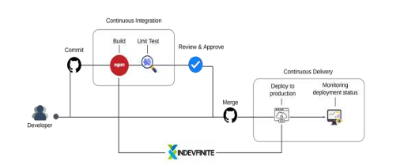
Figure no. 6 CI/CD Pipeline
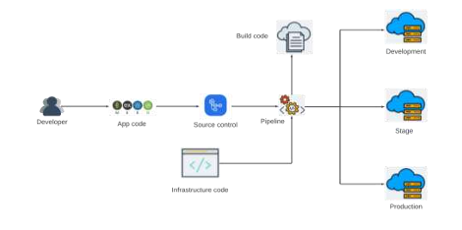
Figure no. 7 Infrastructure as a Code (IaC)

Lorem ipsum dolor sit amet, consectetur adipiscing elit, sed do eiusmod tempor incididunt ut labore et dolore magna aliqua. Ut enim ad minim veniam, quis nostrud exercitation ullamco laboris nisi ut aliquip ex ea commodo consequat. Duis aute irure dolor in reprehenderit in voluptate velit esse cillum dolore eu fugiat nulla pariatur. Excepteur sint occaecat cupidatat non proident, sunt in culpa qui officia deserunt mollit anim id est laborum

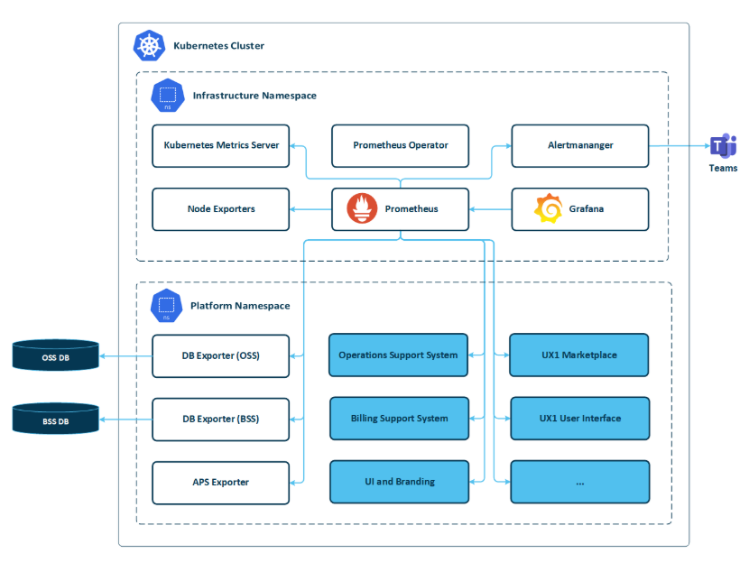
Figure no. 8 Monitoring and Alerting
Lorem ipsum dolor sit amet, consectetur adipiscing elit, sed do eiusmod tempor incididunt ut labore et dolore magna aliqua. Ut enim ad minim veniam, quis nostrud exercitation ullamco laboris nisi ut aliquip ex ea commodo consequat. Duis aute irure dolor in reprehenderit in voluptate velit esse cillum dolore eu fugiat nulla pariatur. Excepteur sint occaecat cupidatat non proident, sunt in culpa qui officia deserunt mollit anim id est laborum

3.7 Integration Approach for Information Systems
The integration approach for the information systems developed Lorem ipsum dolor sit amet, consectetur adipiscing elit, sed do eiusmod tempor incididunt ut labore et dolore magna aliqua. Ut enim ad minim veniam, quis nostrud exercitation ullamco laboris nisi ut aliquip ex ea commodo consequat. Duis aute irure dolor in reprehenderit in voluptate velit esse cillum dolore eu fugiat nulla pariatur. Excepteur sint occaecat cupidatat non proident, sunt in culpa qui officia deserunt mollit anim id est laborum
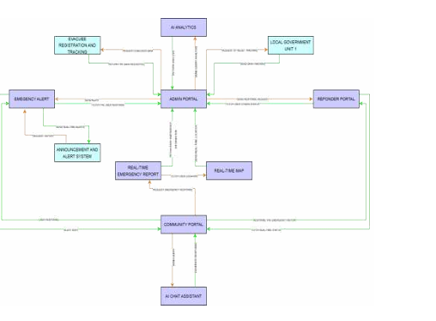
Figure no. 9 Business Process Architecture
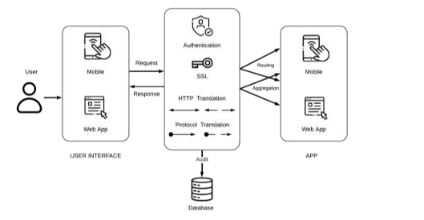
Figure no. 10 API Gateway
Lorem ipsum dolor sit amet, consectetur adipiscing elit, sed do eiusmod tempor incididunt ut labore et dolore magna aliqua. Ut enim ad minim veniam, quis nostrud exercitation ullamco laboris nisi ut aliquip ex ea commodo consequat. Duis aute irure dolor in reprehenderit in voluptate velit esse cillum dolore eu fugiat nulla pariatur. Excepteur sint occaecat cupidatat non proident, sunt in culpa qui officia deserunt mollit anim id est laborum

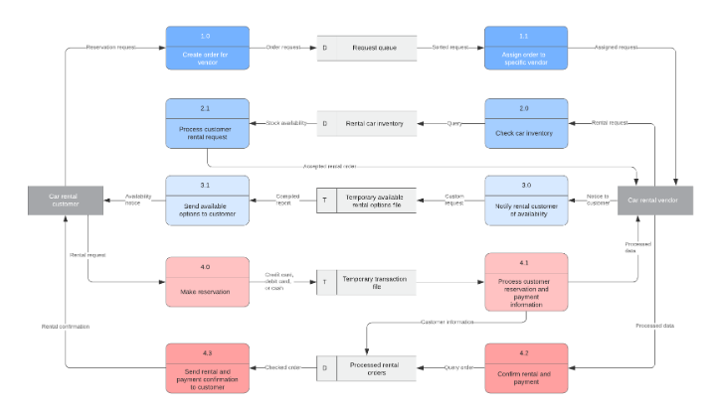
Figure no. 11 Data Flow Diagram
Lorem ipsum dolor sit amet, consectetur adipiscing elit, sed do eiusmod tempor incididunt ut labore et dolore magna aliqua. Ut enim ad minim veniam, quis nostrud exercitation ullamco laboris nisi ut aliquip ex ea commodo consequat. Duis aute irure dolor in reprehenderit in voluptate velit esse cillum dolore eu fugiat nulla pariatur. Excepteur sint occaecat cupidatat non proident, sunt in culpa qui officia deserunt mollit anim id est laborum
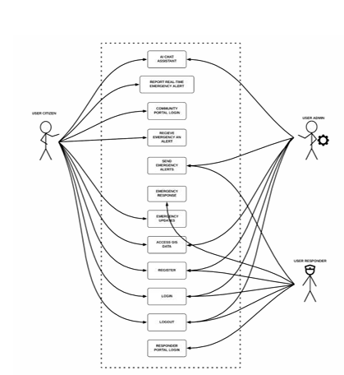
Figure no. 12 Use Case Diagram
Lorem ipsum dolor sit amet, consectetur adipiscing elit, sed do eiusmod tempor incididunt ut labore et dolore magna aliqua. Ut enim ad minim veniam, quis nostrud exercitation ullamco laboris nisi ut aliquip ex ea commodo consequat. Duis aute irure dolor in reprehenderit in voluptate velit esse cillum dolore eu fugiat nulla pariatur. Excepteur sint occaecat cupidatat non proident, sunt in culpa qui officia deserunt mollit anim id est laborum

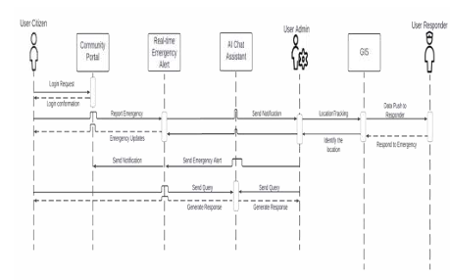
Figure no. 13 Sequence Diagram
Lorem ipsum dolor sit amet, consectetur adipiscing elit, sed do eiusmod tempor incididunt ut labore et dolore magna aliqua. Ut enim ad minim veniam, quis nostrud exercitation ullamco laboris nisi ut aliquip ex ea commodo consequat. Duis aute irure dolor in reprehenderit in voluptate velit esse cillum dolore eu fugiat nulla pariatur. Excepteur sint occaecat cupidatat non proident, sunt in culpa qui officia deserunt mollit anim id est laborum
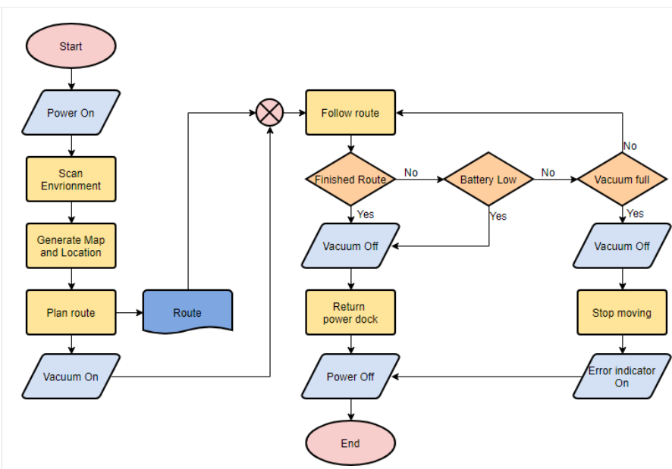
Figure no. 14 Flowchart
Lorem ipsum dolor sit amet, consectetur adipiscing elit, sed do eiusmod tempor incididunt ut labore et dolore magna aliqua. Ut enim ad minim veniam, quis nostrud exercitation ullamco laboris nisi ut aliquip ex ea commodo consequat. Duis aute irure dolor in reprehenderit in voluptate velit esse cillum dolore eu fugiat nulla pariatur. Excepteur sint occaecat cupidatat non proident, sunt in culpa qui officia deserunt mollit anim id est laborum

3.8 Introduction to TOGAF and the Four Architectural Domains
1. Business Architecture
Lorem ipsum dolor sit amet, consectetur adipiscing elit, sed do eiusmod tempor incididunt ut labore et dolore magna aliqua. Ut enim ad minim veniam, quis nostrud exercitation ullamco laboris nisi ut aliquip ex ea commodo consequat. Duis aute irure dolor in reprehenderit in voluptate velit esse cillum dolore eu fugiat nulla pariatur. Excepteur sint occaecat cupidatat non proident, sunt in culpa qui officia deserunt mollit anim id est laborum
2. Data Architecture
Lorem ipsum dolor sit amet, consectetur adipiscing elit, sed do eiusmod tempor incididunt ut labore et dolore magna aliqua. Ut enim ad minim veniam, quis nostrud exercitation ullamco laboris nisi ut aliquip ex ea commodo consequat. Duis aute irure dolor in reprehenderit in voluptate velit esse cillum dolore eu fugiat nulla pariatur. Excepteur sint occaecat cupidatat non proident, sunt in culpa qui officia deserunt mollit anim id est laborum.
3. Application Architecture
Lorem ipsum dolor sit amet, consectetur adipiscing elit, sed do eiusmod tempor incididunt ut labore et dolore magna aliqua. Ut enim ad minim veniam, quis nostrud exercitation ullamco laboris nisi ut aliquip ex ea commodo consequat. Duis aute irure dolor in reprehenderit in voluptate velit esse cillum dolore eu fugiat nulla pariatur. Excepteur sint occaecat cupidatat non proident, sunt in culpa qui officia deserunt mollit anim id est laborum.
4. Technology Architecture
Lorem ipsum dolor sit amet, consectetur adipiscing elit, sed do eiusmod tempor incididunt ut labore et dolore magna aliqua. Ut enim ad minim veniam, quis nostrud exercitation ullamco laboris nisi ut aliquip ex ea commodo consequat. Duis aute irure dolor in reprehenderit in voluptate velit esse cillum dolore eu fugiat nulla pariatur. Excepteur sint occaecat cupidatat non proident, sunt in culpa qui officia deserunt mollit anim id est laborum.

CHAPTER IV
4 Requirements Analysis
4.1. Stakeholder Identification
4.2. Requirements Gathering Techniques
4.3. User Stories and Use Cases
4.4. Functional Requirements for Integration
5 Business Process Architecture
5.1. Identification of Business Processes
5.2. Business Process Diagrams
5.3. Alignment of Integrated System with
Business Processes
5.4. Business Process Improvements
6 Application Architecture
6.1. Components of Application Architecture
6.2. Application Architecture Diagrams
6.3. Integration of Software Modules
6.4. Communication and Interaction Patterns
7 Data Architecture
7.1. Data Sources and Types
7.2. Data Flow Diagrams
7.3. Data Storage and Management
7.4. Data Synchronization Across Systems
8 Technology Architecture
8.1 Technology Stack and Infrastructure
8.2 Software Technologies
8.3. Scalability and Performance Considerations
9 Development Process
9.1. Agile Scrum Roles and Responsibilities
9.2. Sprint Planning and Backlog Management
9.3. Sprint Execution and Deliverables
9.4. Challenges Faced In the Development Process
10 Implementation
10.1. Technical Implementation Details
10.2. Tools and Technologies Used
10.3. Code Integration and Interoperability
10.4. Integration Testing and Debugging
11 Testing and Quality Assurance
11.1. Testing Strategies and Methodologies
11.2. Test Cases and Test Data
11.3. Test Results and Bug Reports
11.4. Quality Assurance Measures
12 Results and Evaluation
12.1. Project Outcomes and Deliverables
12.2. Alignment with Project Objectives
12.3 Stakeholder and User Feedback
12.4. Lessons Learned
CHAPTER V
13 Conclusion
13.1. Key Takeaways and Summary
13.2. Project Achievements and Contributions
13.3. Future Work and Enhancements
13.4. Closing Remarks

APPENDICES
Appendix A : Detailed Technical Documentation
1. System Architecture
2. Information Systems Integration
3. Application Design and Development
4. Database Schema and Data Management:
5. Network Configuration
6. Deployment and Infrastructure
7. Security Measures:
8. Testing and Quality Assurance
9. System Monitoring and Maintenance:
10. APIs and Integration Points:
11. User Documentation:
12. Known Issues and Troubleshooting
13. Version Control and Source Code Repository
14. DevOps and Continuous Integration/Continuous Deployment (CI/CD):
15. Licensing and Open Source Libraries:
16. Performance Metrics and Monitoring:

Appendix B : Documents/URLs
1.Adviser Acceptance (signed)
2. Company Confirmation (signed)
3. Panel Evaluation and Signature (plus photo ops during defense)
4. Pilot Companies’ Background with proofs of interviews
5. Link to codes (good for 3 years)
6. Link to documentation (good for 3 years)
7. Link to demo video guide (good for 3 years

Appendix C: Certificate of Originality
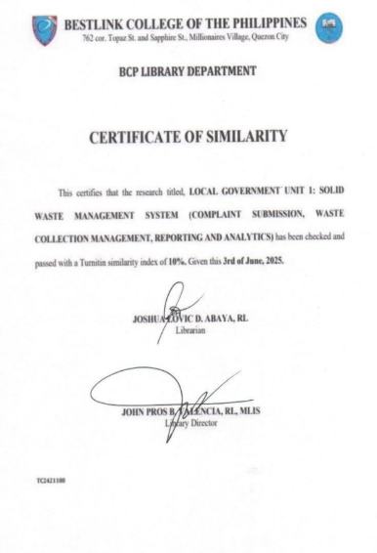

Appendix D: Certificate of Grammarian
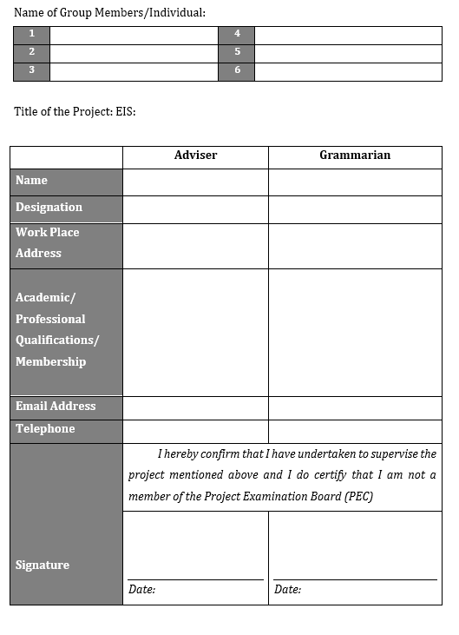
Appendix E : Grammarian Curriculum Vitae

Appendix F : Technical Adviser Curriculum Vitae

Appendix G: Research Adviser Curriculum Vitae
Appendix H : Researcher’s Curriculum Vitae

